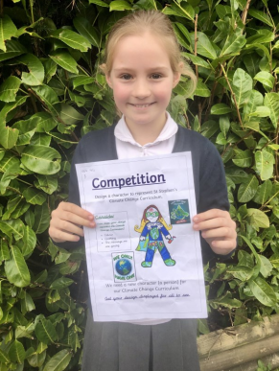
Sustainable Citizen Character Competition
Children's' Rights Article 24: Every child has the right to the best possible
health. Governments must provide good quality health care, clean water,
nutritious food and a clean environment so that children can stay healthy.
A HUGE well done to everyone who has entered the competition set by our
UNICEF Steering Group. We are delighted that children across all ages have
submitted their ideas. As a school we recognise it is our responsibility to care
for our planet and as a school community we are working hard to plan
lessons into our curriculum offer and to identify ways we can make a real
difference in a practical way.
As a school, we are committed to reducing our waste of paper, food, plastics and energy. Incorporating intelligent heat usage and heat loss prevention, paper reduction and online communications and recycling.
We already raise awareness of climate change within the school and local community through our weekly SMSC, assemblies and events.
As a school, we promote walking and cycling where possible to reduce excess pollution and energy usage.
With the help of the community, through the UNICEF steering committee and staff we are committed to
research in order to improve and evolve our response to climate change. This is an ongoing and continual process.
The winner was announced in our whole school assembly on Monday. A HUGE well done to Jessy We agreed her eye-catching image evoked the Sustainable Citizen' brilliantly and it will be used on all our displays and paperwork linked to this very important area of the curriculum. Thank you to everyone who entered. 